**Chapter 11 Tax**

*In This Chapter:*

**11.1 SST Processor**

**11.2 Tax Code Maintenance**

**11.1 SST Processor**

* To open SST Processor, on the **SmartLeg@l** navigation, click Tax and go to **SST Processor**.

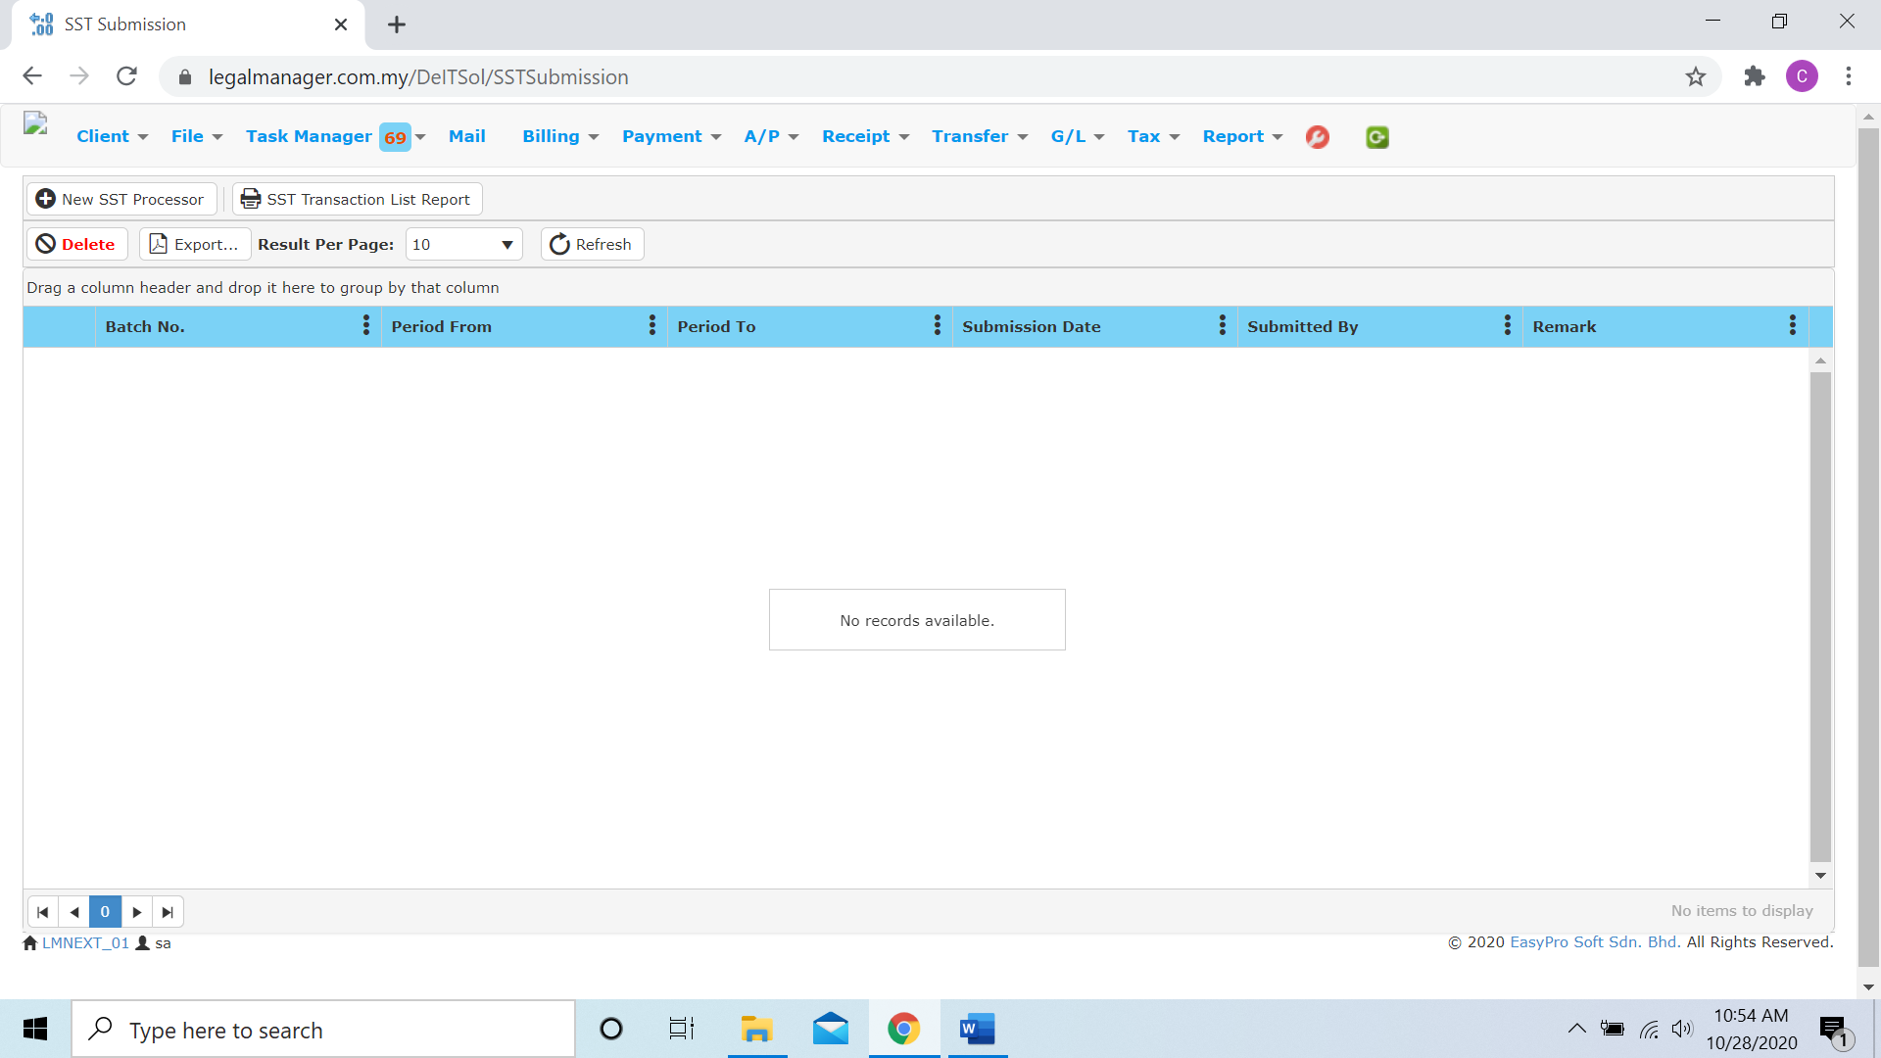

* Click ‘**Export**’ to print the desired search results in txt, excel or html format.
* Click ‘**Delete**’ to delete the selected record
* If there do not have any SST Processor records it will show no records available and you may click New SST Processor  to create a record
* When you decide to create a SST Processor, after you click that it will pop up a SST Processor Wizard as figure below shown

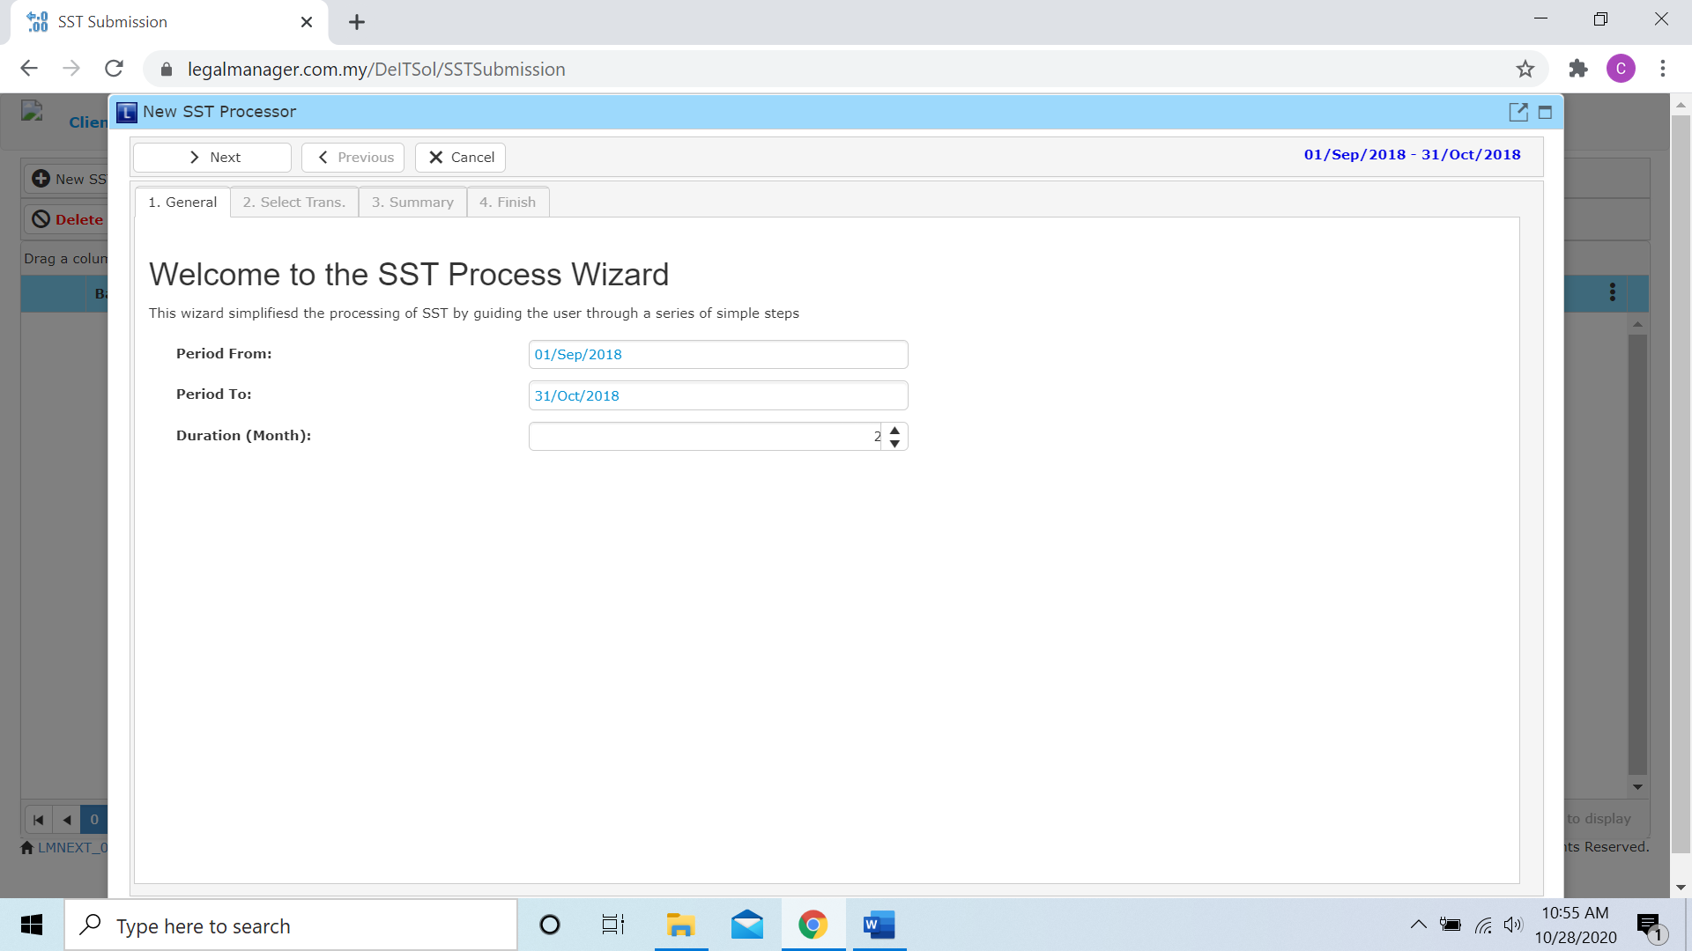

* The Period From is fixed, however you can decide the Period To by increase or decrease the duration
* After that, click to the next you may go to ‘Select Trans’

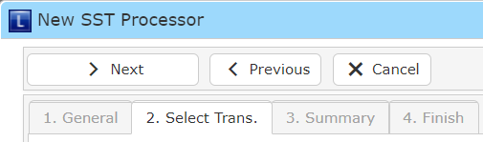

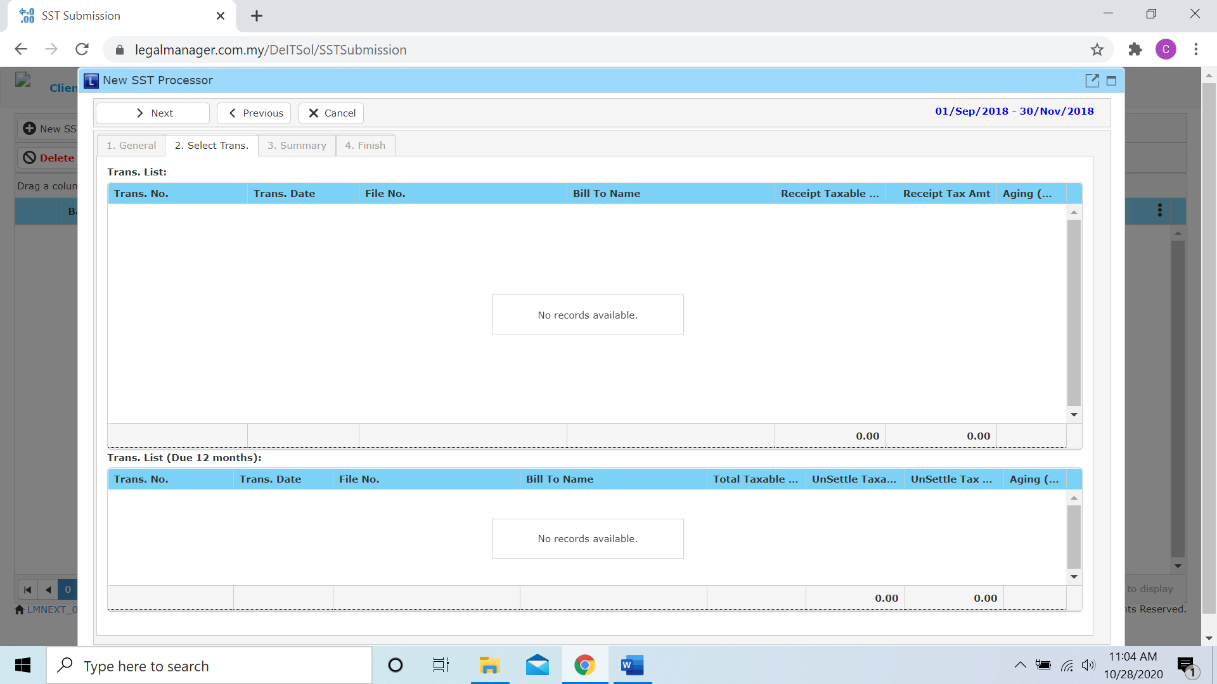

* You can select trans from the list of both table
* After you selected trans, click to next tab ‘Summary’

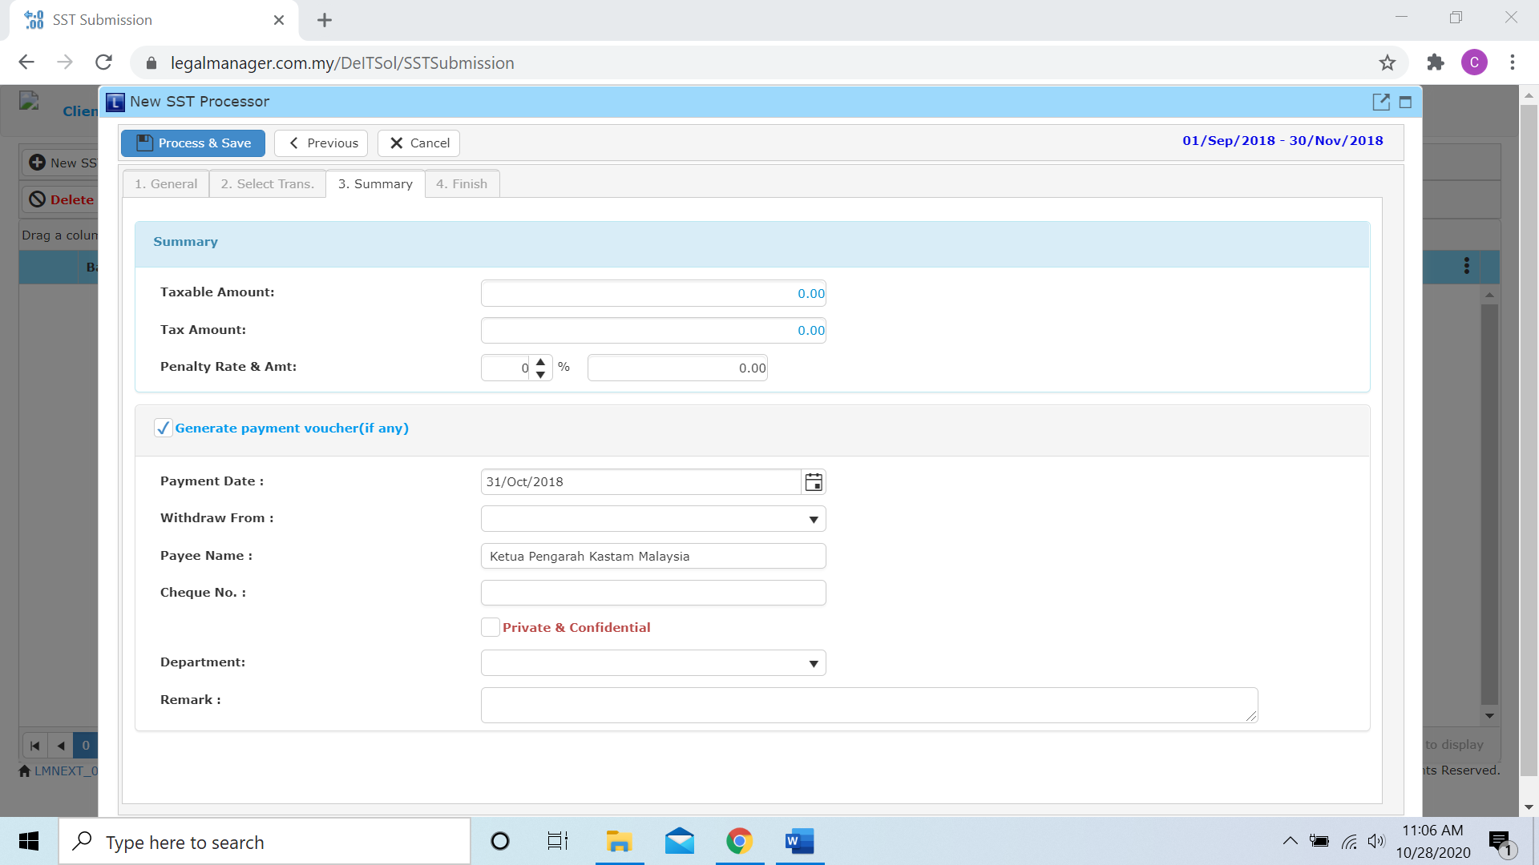

* You can adjust the penalty rate and amount
* You can key in the date or click to the calendar icon to choose the date
* Choose a account from withdraw and department from combo box
* Key in cheque number and remark if necessary
* Private and confidential is compulsory
* After you click to ‘Save’, it will directly go to the ‘Finish’ Tab

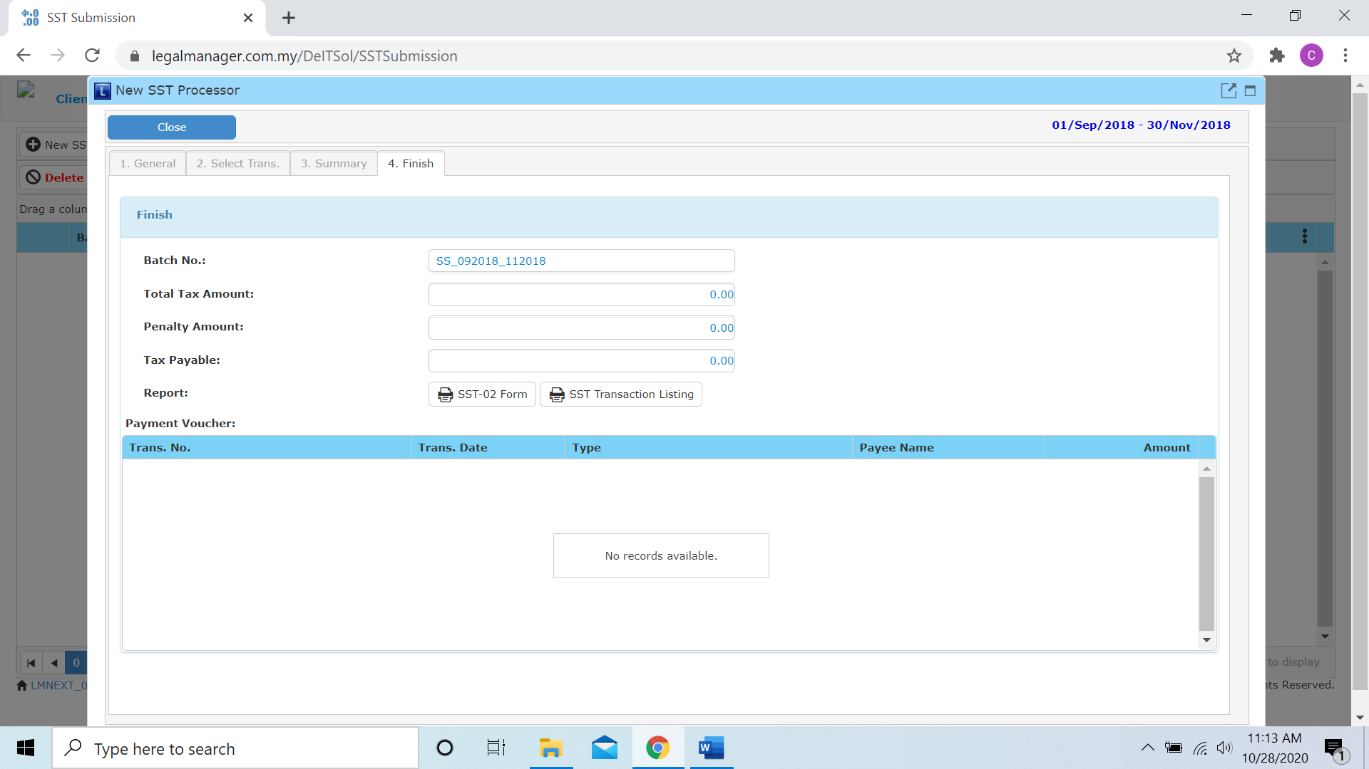

* You can print or preview the SST Transaction List Report while you click to 
* It will pop-up a SST Transaction List Report as below and you can insert you requirement to filter the report
* Besides, you can preview the report

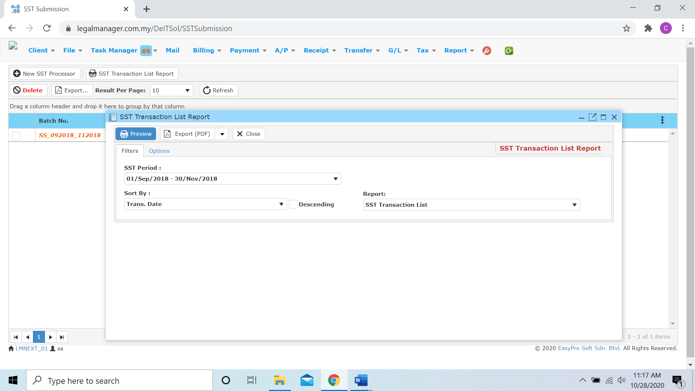

* You can also export the report into PDF or excel by clicking

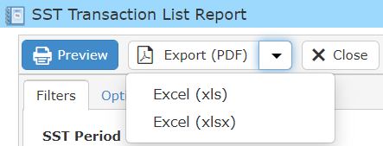

**11.2 Tax Code Maintenance**

* To open Tax Code Maintenance, on the **SmartLeg@l** navigation, click Tax and go to **Tax Code Maintenance**

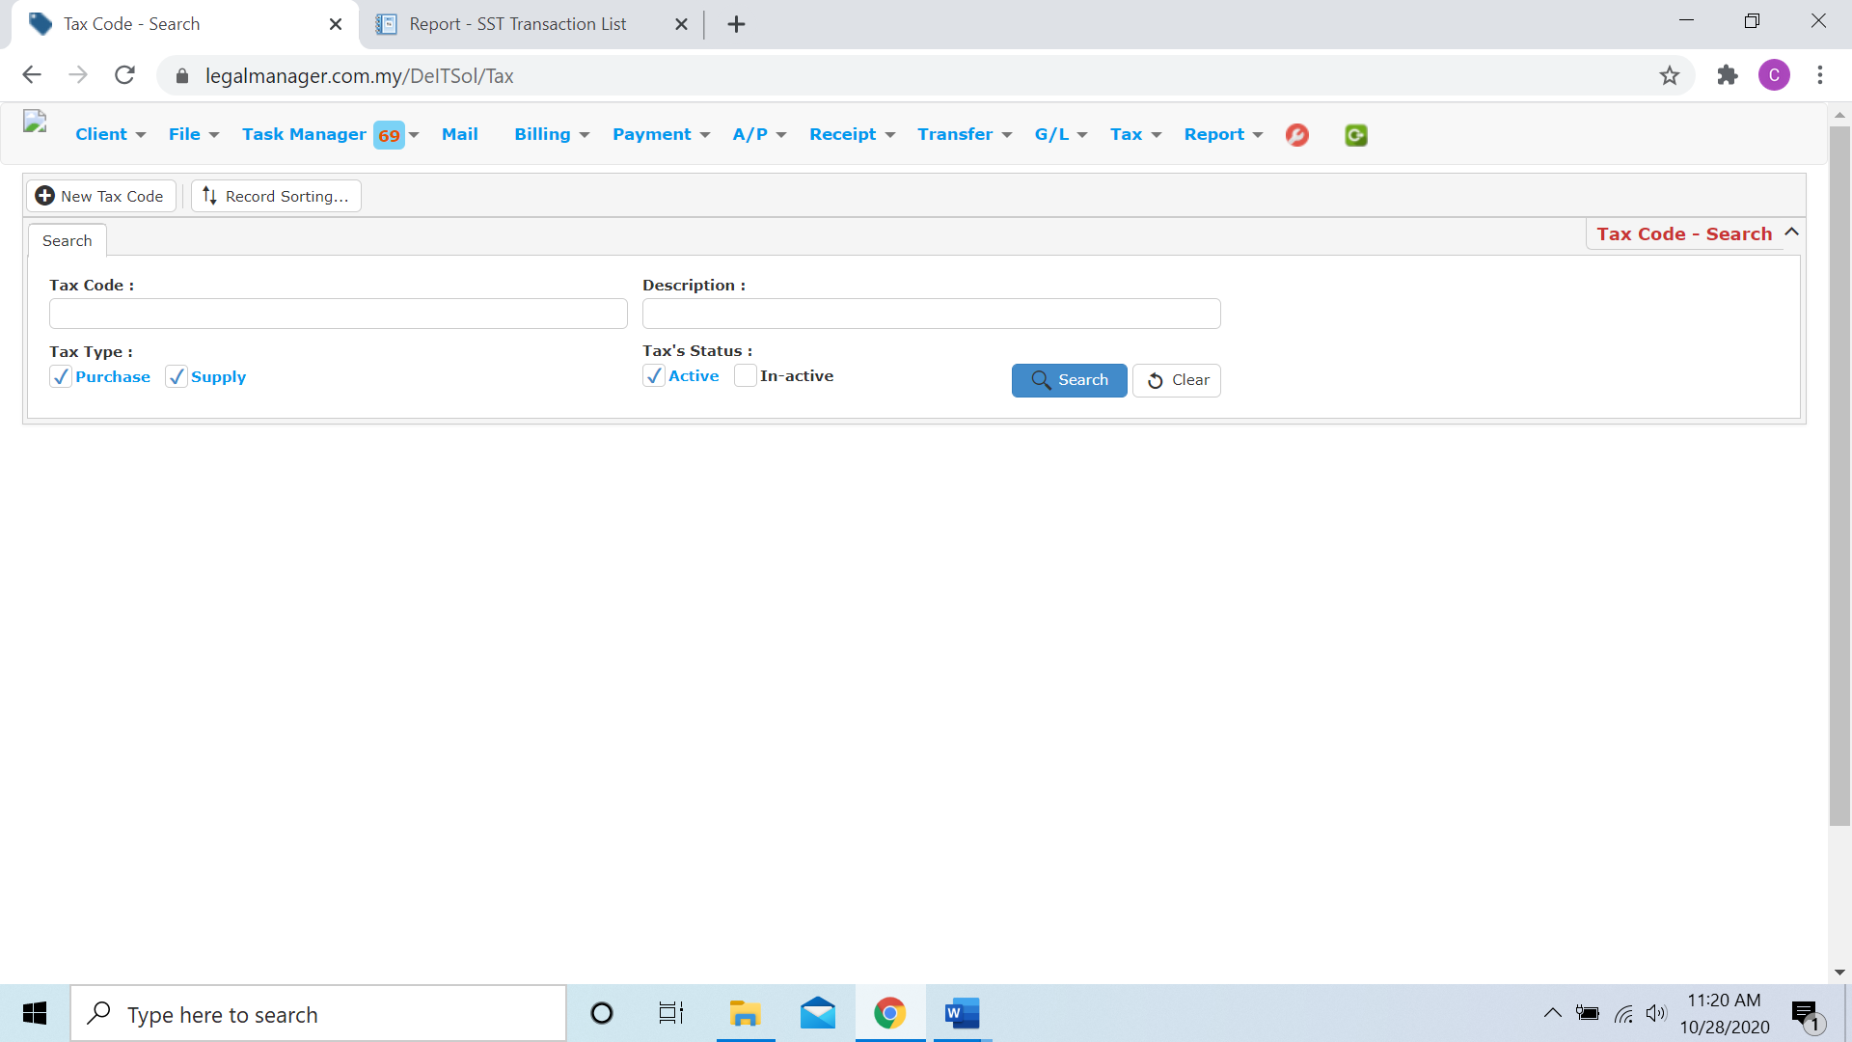

* You can enter tax code, description and choose tax type and status to search a tax code
* Click search once to browse all tax code as figure below shown
* To start a new search or to clear the search results, click ‘**Clear**’.

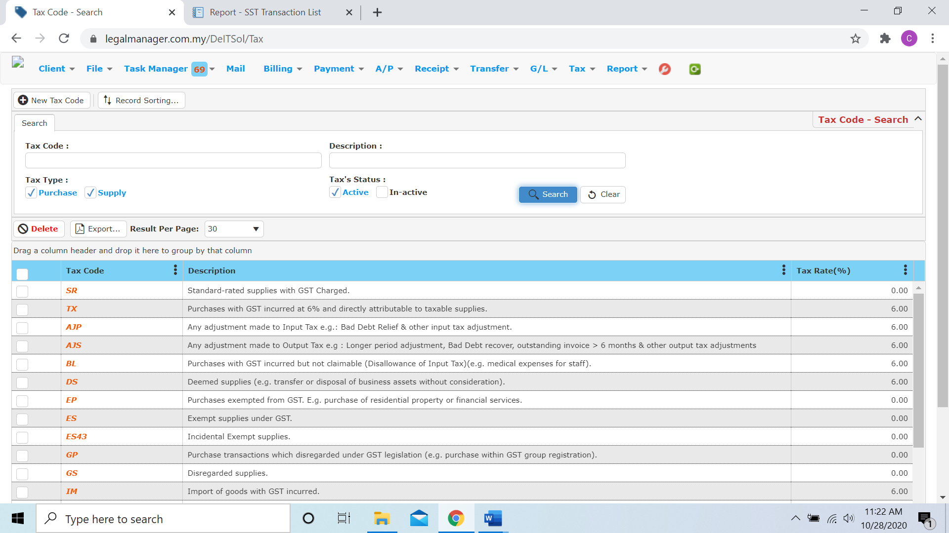

* Other than Search Tax Code you can create of New Tax Code by clicking  and it will pop up Tax Code Details input form

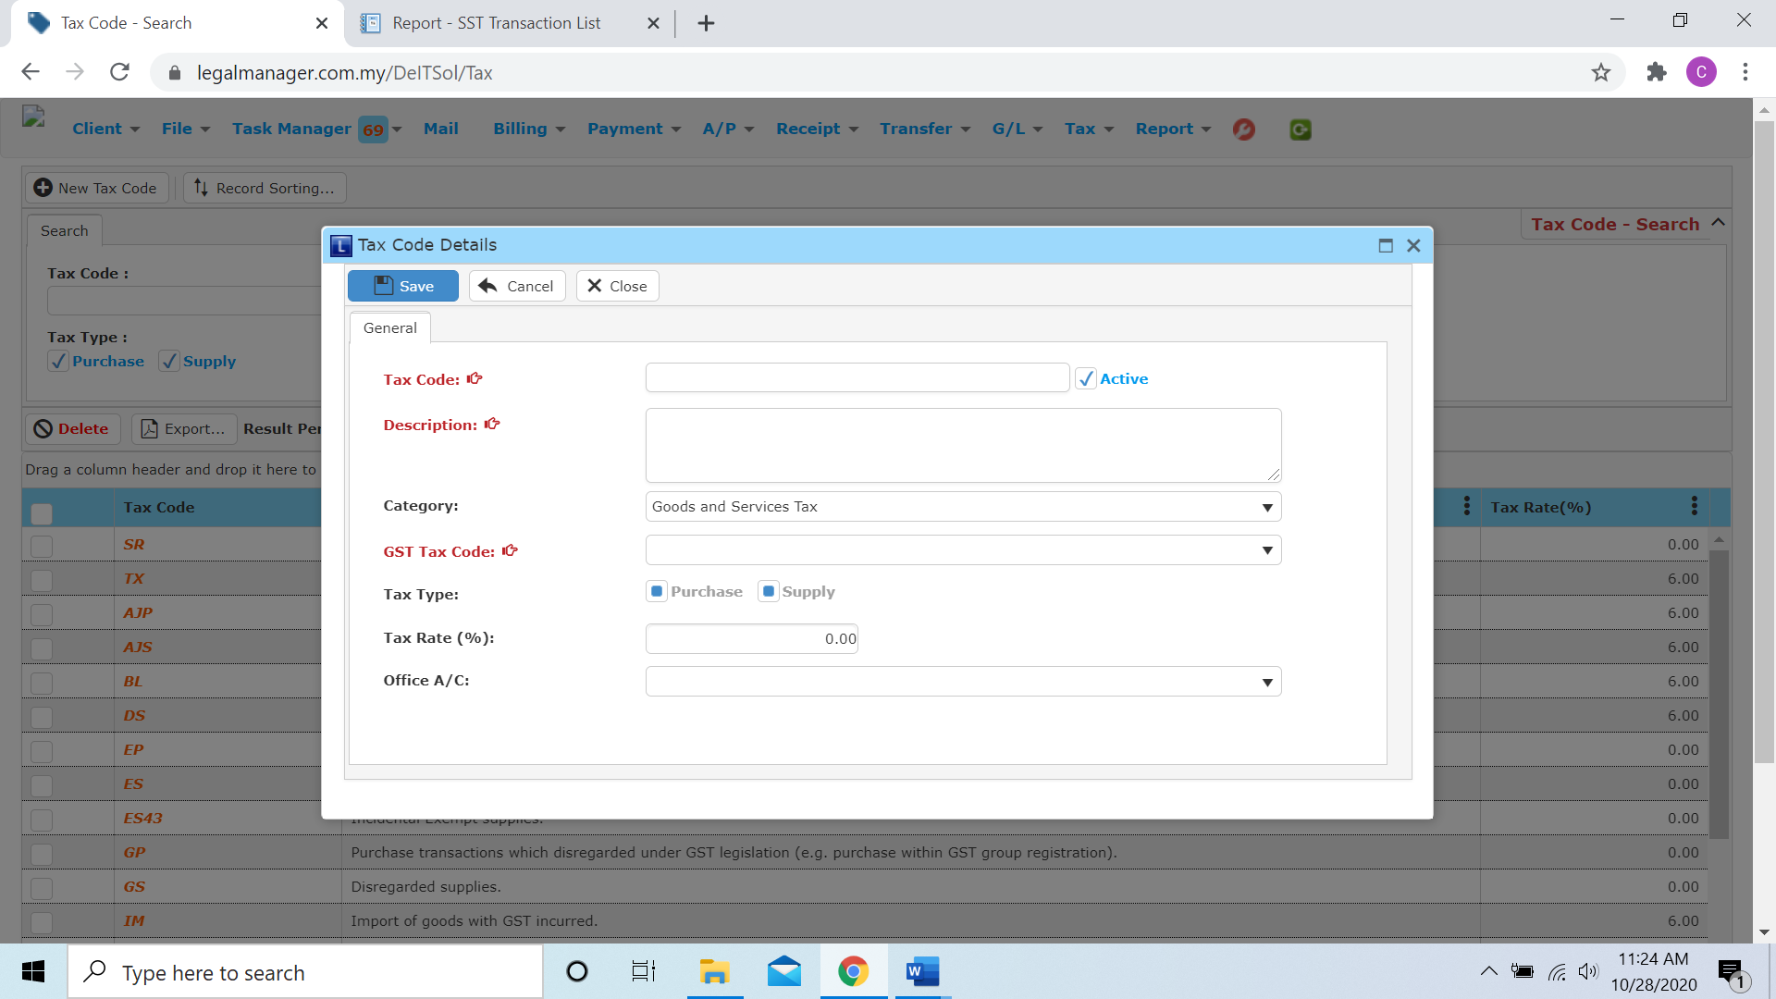

* Insert the Tax Code, Description and GST Tax Code is compulsory
* Moreover, you can adjust other info like tax rate, choose office a/c

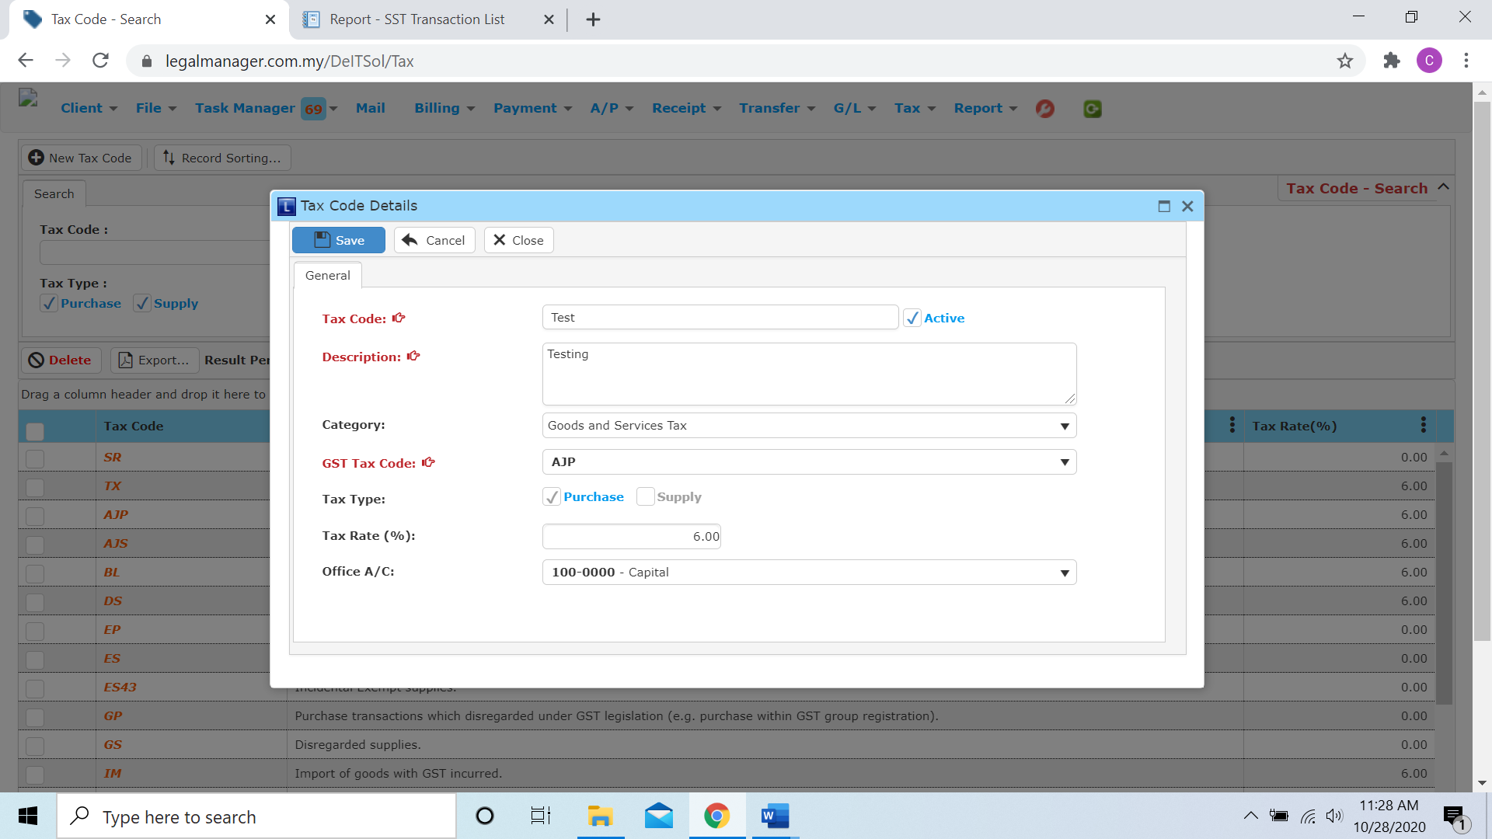

* After you finish the tax code details, click ‘Save’ and the tax code will appeal in the tax code maintenance search list
* In addition, you can sort the all the tax code in tax code maintenance by clicking 

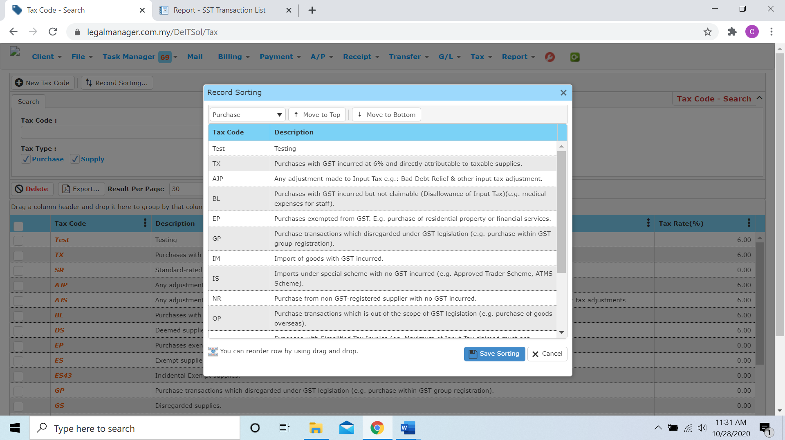

* The system will pop up a record sorting wizard, you can make arrangement for all the tax code.